Chiropractic Documentation is identified in the Third Party world as generally insuffecient to document medical necessity and document the basis for treatment.

Let’s take a look at some facts

Evaluation of Chiropractic Documentation by the Office of the Inspector General for Medicare and by a Mississippi Carrier.

Background

•In 1972, Congress passed Public Law 92-603, which amended section 1861(r) of the Social Security Act (the Act) to define chiropractors as physicians who are eligible for Medicare reimbursement, but only for manual manipulation of the spine to correct a subluxation, or malfunction of the spine.

•Federal regulations (42 CFR § 410.21(b)) further limit Medicare payment to treatment of subluxations that result in a neuromusculoskeletal condition for which manual manipulation is appropriate treatment.

•In addition to these specific provisions, sections 1862(a)(1)(A) and 1833(e) of the Act require that all services billed to Medicare, including chiropractic manipulations, be medically necessary and supported by documentation.

•The Medicare Carriers Manual (the Manual) outlines additional coverage criteria for chiropractic services billed to Medicare.1 Pursuant to section 2251.2 of the Manual, the existence of a subluxation must be documented through an X-ray or physical examination and chiropractic services must be provided as part of a written plan of care that should include specific goals and measures to evaluate effectiveness.

•Section 2251.3 of the Manual states that chiropractic treatment “. . . must provide a reasonable expectation of recovery or improvement of function.”

•The same Manual section states that “. . . ongoing maintenance therapy is not considered to be medically necessary under the Medicare program,” and is therefore noncovered.

•Chiropractic has experienced considerable growth in Medicare, from 11.2 million services and $255 million allowed in 1994 to 21 million services and $683 million allowed in 2004.

•In previous studies, published in 1986, 1998, and 1999, the Inspector General found that a significant vulnerability existed in connection with chiropractic services, particularly concerning maintenance care.

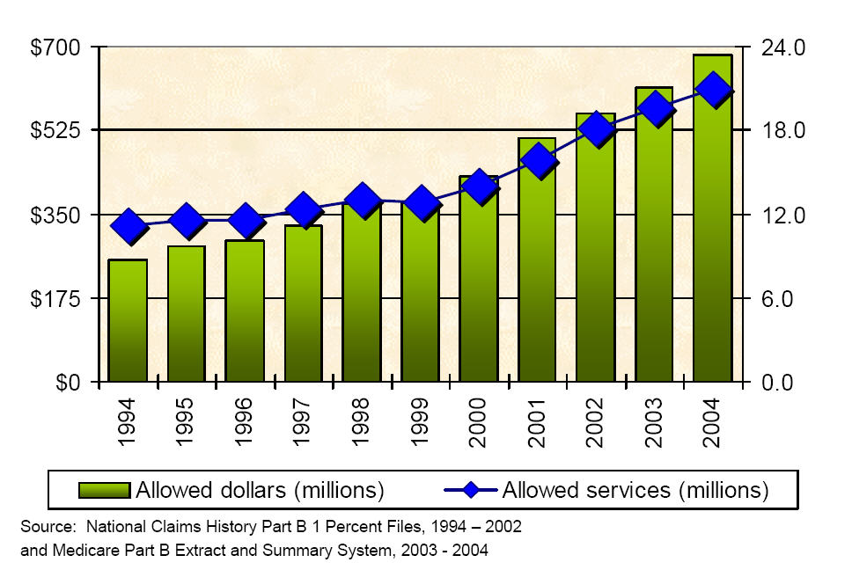

How was the audit done?

•A simple random sample of 400 Medicare services (total allowed amount = $12,638.38) submitted by chiropractors and allowed in 2001.

•OIG contracted with practicing chiropractors who reviewed each service according to a standard protocol, which was based on Medicare coverage guidelines and requirements.

•The review instrument solicited information about the beneficiary’s chiropractic treatment as a whole and about the individual sampled service in particular.

•This enabled the reviewers to determine if the services billed to Medicare were covered, coded correctly, and properly documented.

•Maintenance services were the most common type of noncovered chiropractic services that Medicare paid for in 2001.
–57 percent of these services did not meet Medicare coverage criteria (i.e., were noncovered).
–In addition, 16 percent were miscoded or billed at the wrong level of spinal manipulation, and
–6 percent were undocumented.
–Twelve percent had multiple errors,
•Yielding an overall error rate of 67 percent, resulting in $285 million in improper payments.

What Was Found?

•Medical reviewers determined that the majority of inappropriately paid services were maintenance treatments ($186 million in allowed payments), which Medicare defines as medically unnecessary, and are therefore not covered.

•Another 14 percent ($65 million) were found to be medically unnecessary for other reasons.

•Medicare also allowed $24 million for services billed with a spinal manipulation code that were actually extraspinal manipulations or non-manipulative treatment, such as massage.

•Apart from coverage issues, upcoding was also a significant problem, resulting in a $15 million overpayment.

•Supporting documentation for chiropractic services rarely met all Medicare Carriers Manual requirements.

•Nearly 94 percent of chiropractic services lacked at least one of the supporting documentation elements listed in section 2251.2 of the Manual (including those that were completely undocumented).

•The lack of one or more of these elements did not automatically lead us to conclude a service was noncovered, although these determinations were often related.

•For instance, 34 percent of chiropractic services were not supported by an evaluation that met the Manual’s specific requirements for documenting a subluxation.

•Most, but not all, of these services were also determined to be noncovered.

•Lack of medical necessity is directly related to service volume.

•As chiropractic care extends beyond 12 treatments in a year, it becomes increasingly likely that individual services are medically unnecessary.

•The likelihood of a service being medically unnecessary increases even more significantly after 24 treatments.

•Accordingly, identifying and carefully scrutinizing services beyond a certain frequency threshold could result in significant savings.

•Although frequency-based controls are common among carriers and in the private sector, the Centers for Medicare & Medicaid Services (CMS) does not have a national policy addressing their use.

•Carrier controls to prevent overutilization are inconsistent.

•Although all carriers have some mechanisms to prevent and recoup improper payments for chiropractic services, a significant vulnerability surrounding this benefit persists.

OIG Recommendations

•Based on the volume of medically unnecessary, undocumented, and noncovered services allowed, chiropractic services represent a significant vulnerability for the Medicare program.

•Therefore, we recommend that CMS take the following actions:

•Ensure that chiropractic services comply with Medicare coverage criteria.
–CMS should require that its carriers or Program Safeguard Contractors conduct service-specific reviews of chiropractic services to identify improper payments.
–CMS should also implement national frequency-based controls to target high-volume services for review, since our medical review identified a strong correlation between high service volume and lack of medical necessity.
–When conducting reviews of individual providers, it is imperative that reviewers collect the entire records associated with services selected as part of a service-specific review.
–Several records we reviewed would have appeared legitimate for any one particular day of service; however, that day’s documentation was repeated verbatim for the entirety of the patient’s treatment.

•Require that its carriers educate chiropractors on Medicare Carriers Manual requirements for supporting documentation.
–Many chiropractors seem unaware of the specific documentation requirements outlined in the Manual.
–CMS should address this lack of knowledge by directing its carriers to issue provider bulletins reminding chiropractors of their responsibilities.

AGENCY COMMENTS AND OIG RESPONSE

•In its comments on our draft report, CMS agreed with our findings and recommendations.

•The agency has clarified its chiropractic coverage criteria and indicated that most carriers are taking steps to reduce chiropractic error rates, including targeted educational efforts and service-specific medical reviews.

•In addition, as of October 1, 2004, CMS has required that chiropractors use the –AT modifier to indicate that a service is not maintenance; only claims to which this modifier is attached are payable.

Maintenance Care

•section 2251.3 of the Manual states that “. . . [a] treatment plan that seeks to prevent disease, promote health and prolong and enhance the quality of life, or therapy that is performed to maintain or prevent deterioration of a chronic condition is not a Medicare benefit. Once the maximum therapeutic benefit has been achieved for a given condition, ongoing maintenance therapy is not considered to be medically necessary under the Medicare program.” In other words, Medicare covers only treatment of acute or chronic subluxations, not preventive or maintenance care.

Maintenance services were the most common type of noncovered chiropractic services that Medicare paid for in 2001

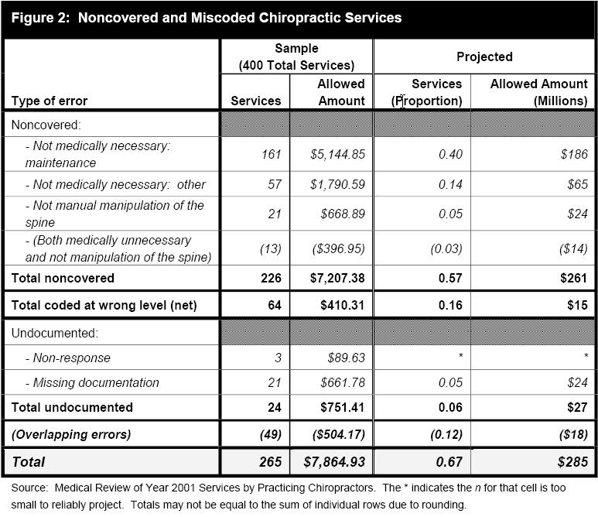

Improper Documentation

•Supporting documentation for chiropractic services rarely met all Medicare Carriers Manual requirements
–Separate from the completely undocumented services previously discussed, nearly 94 percent of chiropractic services lacked some or all of the supporting documentation that section 2251.2 of the Manual requires.

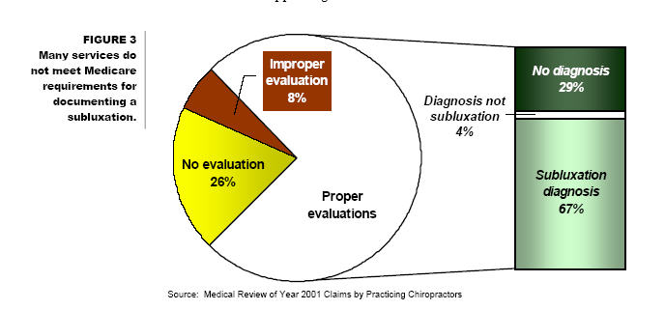

Evaluation of the OIG of Chiropractic records, May 2009
http://oig.hhs.gov

OBJECTIVE
To determine the extent to which:
- chiropractic claims allowed in 2006 for beneficiaries receiving more than 12 services from the same chiropractor were appropriate,
- controls ensured that chiropractic claims were not for maintenance therapy,
- claims data can be used to identify maintenance therapy, and
- chiropractic claims were documented as required.

FINDINGS
Medicare inappropriately paid $178 million for chiropractic claims in 2006, representing 47 percent of claims meeting our study criteria
In 2006, Medicare inappropriately paid $178 million (out of $466 million) for chiropractic claims for services that medical reviewers determined to be maintenance therapy ($157 million), miscoded ($11 million), or undocumented ($46 million). These claims represent 47 percent of all allowed chiropractic claims that met the study criteria. Claims representing $36 million had multiple errors.

Efforts to stop payments for maintenance therapy have been largely ineffective. CMS, carriers, and program safeguard contractors (PSC) use a number of strategies to deter inappropriate payments for maintenance therapy, including use of the AT modifier to indicate active/corrective treatment, provider education, frequency-based control edits (caps), and focused medical review. Despite these efforts, carriers and PSCs continue to report high errors for chiropractic claims. Carrier staff, PSC staff, and medical reviewers for this study agreed that the AT modifier did not prevent inappropriate payments for maintenance therapy because chiropractors continued to submit claims for maintenance therapy with the AT modifier.
Claims data lack initial visit dates for treatment episodes, hindering the identification of maintenance therapy. To identify active/corrective treatment and thereby distinguish it from maintenance therapy, it is useful to identify the start of a new treatment episode. However, claims data do not indicate when an episode begins. Thus, we asked sampled chiropractors and the medical reviewers to identify when an episode began and ended. Overall, only 50 percent of all treatment episodes remained active/corrective throughout the treatment episode. In addition, 78 percent of those treatment episodes that became maintenance therapy did so by the 20th visit. The Comprehensive Error Rate Testing (CERT) paid claims error rate used by CMS is based on a review of a single claim, which limits its ability to detect maintenance therapy and may underestimate errors in claims for chiropractic services.
Chiropractors often do not comply with the Manual documentation requirements. Separate from the undocumented claims counted as errors above, 83 percent of chiropractic claims failed to meet one or more of the documentation requirements. Consequently, the appropriate use of the AT modifier could not be definitively determined through medical review for 9 percent of sampled claims, representing $39 million.
The medical reviewers indicated that treatment plans are an important element in determining whether the chiropractic treatment was active/corrective in achieving specified goals. Of the 76 percent of records that reviewers indicated contained some form of treatment plan, 43 percent lacked treatment goals, 17 percent lacked objective measures, and 15 percent lacked the recommended level of care.
RECOMMENDATIONS
Medicare continues to pay inappropriately for maintenance therapy despite acknowledging this vulnerability in response to previous Office of Inspector General work and subsequent efforts aimed at prevention. Because of high error rates and poor documentation, we recommend that CMS:
Implement and enforce policies to prevent future payments for maintenance therapy. CMS can achieve this by implementing a new modifier for chiropractic claims to indicate the start of a new treatment episode and/or implementing a cap on allowed chiropractic claims.
Review treatment episodes rather than individual chiropractic claims to strengthen the ability of the CERT to detect errors in chiropractic claims. CMS should consider expanding the CERT review from a single sampled claim to a treatment episode that includes all claims from the initial visit to the sampled claim for a sample of (1) all chiropractic claims or (2) chiropractic claims for beneficiaries receiving 12 or more services per year because of their increased vulnerability. Under this review, CMS would continue to sample claims in the current CERT process but would also request associated claims prior to the sampled claims to augment the medical review.
Ensure that chiropractic claims are not paid unless documentation requirements are met. CMS can achieve this by requiring carriers, whose responsibilities will transition to Medicare Administrative Contractors (MAC) by 2011, to withhold payment on reviewed claims when required documentation is absent or requiring carriers/MACs to perform prepayment review of claims from chiropractors who repeatedly fail to meet documentation requirements.
Take appropriate action regarding the undocumented, medically unnecessary, and miscoded claims identified in our sample.

AGENCY COMMENTS AND OFFICE OF INSPECTOR GENERAL RESPONSE
In its written comments on the report, CMS agreed with the second recommendation and described actions it would take to address the fourth recommendation. CMS did not indicate agreement or disagreement with the first and third recommendations.
In response to the second recommendation, CMS indicated that it is now reviewing 6 months of claims prior to sampled claims in response to a recommendation from a prior OIG report. As a result, the CERT error rate increased from 8.9 percent to 15.3 percent from 2005 to 2006. CMS indicated it would have to conduct a cost-benefit analysis to determine the utility of expanding this review to include claims beginning with the first claim of the treatment episode. We encourage CMS to conduct this analysis because the intent of CERT is to determine error rates, identify programs at risk, and prevent future overpayments. OIG has repeatedly found overpayments for maintenance therapy.
In response to the fourth recommendation, CMS stated that it would instruct the contractors to take any necessary corrective actions with respect to the sampled claims that this study identified as being in error.
In response to the first recommendation, CMS indicated that the objective data required to impose a national cap on the number of chiropractic services does not currently exist. In response to the third recommendation, CMS described the current process contractors use to review provider claims with a greater likelihood of payment error, but CMS indicated no change in future practice to prevent claims without required documentation from being paid in error. We ask that in its final management decision, CMS more clearly indicate whether it concurs with our first and third recommendations and what steps, if any, it will take to implement them.
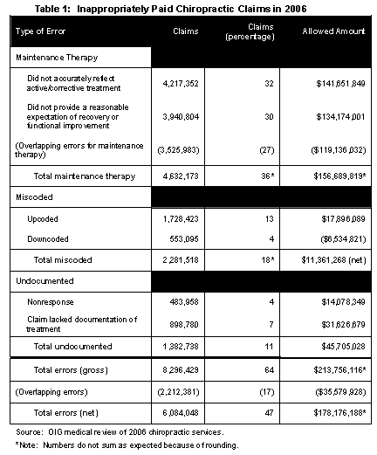

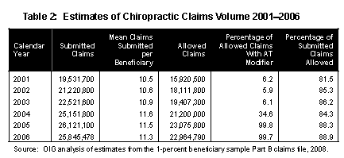

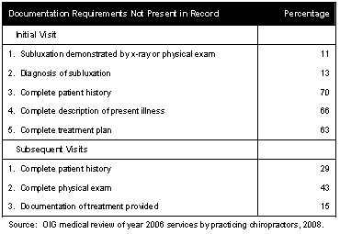

Table A-1: Documentation Errors for Sampled Records
Point Estimate 95-Percent Confidence
Documentation Requirements Not Present n (percentage) Interval
Initial Visit
1. Subluxation demonstrated by x-ray or physical exam | 188 | 11 | 7–17
2. Diagnosis of subluxation | 188 | 13 | 9–19
3. Complete patient history | 188 | 70 | 63–77
Any patient history | 188 | 6 | 3–11
- symptoms causing patient to seek treatment | 176 | 2 | 0–5
- family history, if relevant | 176 | 2 | 1–6
- past health history | 176 | 40 | 33–48
- mechanism of trauma | 176 | 29 | 22–36
- quality and character of symptoms | 176 | 13 | 8–19
- onset, duration, intensity, frequency, location, and radiation of symptoms | 176 | 22 | 16–29
- aggravating or relieving factors | 176 | 41 | 34–49
- prior interventions, treatments, medications, and secondary complaints | 176 | 42 | 35–50
4. Complete description of present illness | 188 | 66 | 59–73
Any description of present illness | 188 | 7 | 4–12
- mechanism of trauma | 175 | 29 | 23–36
- quality and character of symptoms | 175 | 14 | 9–20
- onset, duration, intensity, frequency, location, and radiation of symptoms | 175 | 22 | 16–29
- aggravating or relieving factors | 175 | 40 | 33–48
- prior interventions, treatments, medications, and secondary complaints | 175 | 43 | 36–51
- symptoms causing patient to seek treatment | 175 | 2 | 0–5
5. Complete treatment plan | 188 | 63 | 55–70
Any treatment plan | 188 | 12 | 8–18
- recommended level of care | 142 | 15 | 9–22
- specific treatment goals | 142 | 43 | 35–52
- objective measures to evaluate effectiveness | 142 | 17 | 11–24
Subsequent Visits
1. Complete patient history | 174 | 29 | 23–37
Any patient history | 174 | 24 | 18–31
- review of chief complaint | 146 | 7 | 3–12
- changes since last visit | 146 | 9 | 5–15
- system review, if relevant | 146 | 0 | 0–3
2. Complete physical exam | 174 | 43 | 35–50
Any physical exam | 174 | 22 | 16–29
- exam of area of spine involved in diagnosis | 149 | 3 | 1–8
- assessment of change in patient condition since last visit | 149 | 15 | 9–22
- evaluation of treatment effectiveness | 149 | 28 | 21–35
3. Documentation of treatment provided | 188 | 15 | 11–21

Source: Office of Inspector General (OIG) analysis of chiropractic claims data, 2008.

Mississippi Medicare Carrier Audit of Chiropractic Claims

Cahaba, The Medicare Carrier for Mississippi, did an audit of chiropractic records during fiscal year 2002. This was done by the medical review unit. This was done based on an analysis of local and national statistical data.

A randomly selected sample of providers was asked to submit documentation specific to the date of service reviewed that supported the services billed. 240 claims with documentation were reviewed for Mississippi providers from specialty 35. Following is a summary of the Medical Review Unit’s findings for these claims.

Documentation of Subluxation based on Physical Examinations

Section 2251.2 , number 2 states “to demonstrate a subluxation, two of the four criteria mentioned under “physical examination” are required, one of which must be asymmetry misalignment or range of motion abnormality.

- Documentation for 20 percent of the claims reviewed did not have the physical examination components supporting the subluxation.

Documentation of Treatment Plan/Plan of Care and Goals

Section 2251.3(C), number 5 states that “The treatment plan should include the following: recommended level of care (duration and frequency of visits), specific treatment goals, and objective measures to evaluate treatment effectiveness..

- Documentation for 5 percent of the claims with treatment plans reviewed were brief or did not consistently state the goals of the treatment/therapy.

- Objective measurements of progress were not consistently identified on 90 percent of records reviewed.

Documentation of Initial Office Visits

Section 2251.2 © states “the following documentation requirements apply whether the subluxation is demonstrated by x-ray or physical examination.”: History as stated above. Description of the present illness including: mechanism of trauma; quality and character of symptoms/problems; onset, duration, intensity, frequency, location, and radiation of symptoms aggravating or relieving factors; prior interventions, treatments, medications, secondary complaints; and symptoms causing patient to seek treatment….evaluation of musculoskeletal/nervous system through physical examination. Diagnosis: The primary diagnosis must be subluxation, including the level of subluxation, either so stated or identified by a term descriptive of subluxation. Such terms may refer to the condition of the spinal joint involved or to the direction of position assumed by the particular bone named. Treatment plan and the date of the initial treatment “in addition, “The subluxation must be causal, i.e., the symptoms must be related to the level o f the subluxation that has been cited. A statement on a claims that is “pain” is insufficient. The location of the pain must be described and whether the particular vertebra listed is capable of producing pain in the area determined.

- The presentation of the signs or symptoms of the subluxation were not adequately documented in 8 percent of claims reviewed, therefore medical necessity of the visit was not established.

Documentation of Treatment Modality

Section 2251.1 states “Manual Manipulation – Coverage of chiropractic is specifically limited to treatment by means of manual manipulation, i.e. by use of hands..Additionally, manual devices (i.e. those that are hand-held with the thrust of the force of the device being controlled manually) may be used by chiropractors in performing manual manipulation of the spine. However, no additional payment is available for the use of the device, nor does Medicare recognize and extra charge for the device itself…Acceptable terminology for the manipulation: Manual adjustment or manipulation vertebral manipulation or adjustment Chiropractic manipulation.”

- Documentation on 3 percent of claims reviewed the modality of treatment was not clearly specified or adequately documented, therefore the use of manual manipulative treatment was not established.

Documentation of Subsequent Office Visits

Section 2251.2 (C) states “Subsequent visits. ---The following documentation requirements apply whether the subluxation is demonstrated by x-ray or by physical examination: 1. History-review of chief complaint, changes since last visits; systems review if relevant. 2. Physical exam- exam of the area of spine involved in diagnosis; assessment of change in patient condition since last visit; Evaluation of treatment effectiveness.”

Documentation for 38 percent of the claims reviewed had one or more of the following problems identified:

- Subsequent exams/assessments on days of treatment/therapy were not consistently documented.
- Subsequent visit records did not consistently document the treatment phase/number of the visit.
- Subsequent visit records did not consistently document changes in the patient’s condition, response to therapy, or the effectiveness of treatment.
- Subsequent visit records did not consistently document what type of modality was utilized in the patient’s treatment (i.e., manual manipulation, heat, massage, etc.)

Exacerbation of Symptoms

An exacerbation is a temporary, marked deterioration of the patient’s condition due to an acute flare-up of the condition being treated. This must be documented on the claim form and must be documented in the patient’s clinical records including the date of occurrence, nature of the onset, or other pertinent factors (i.e. symptoms related to the exacerbation and relevant physical assessment or examination) tat will support the medical necessity of treatment for their condition.

Documentation for 14 percent of the claims reviewed had the following problems identified:

- Exacerbations were not adequately documented according to national guidelines or the documentation reviewed did not support the exacerbation date entered on line 19 of the CMS 1500 form. The actual date of the new or re-injury should be entered on line 19 of the 1500 form, not the date that the patient first sought chiropractic treatment for the injury.

- Documentation reviewed did not state the date of the exacerbation or re-injury, the mechanism of trauma, or the patient’s symptoms. (a specific date is needed. “last week“ or “a few days ago” is insufficient.

Maintenance Therapy/Chronic Subluxation

Section 2251.3(A) defines chronic subluxation as “Chronic subluxation: A patient’s condition is considered chronic when it is not expected to completely resolve (as in the case with an acute condition), bur where the continued therapy can be expected to result in some functional improvement. Once the functional status has remained stable for a given condition, further treatment is considered maintenance therapy and is not covered by the Medicare program.

- All records reviewed did not contain documentation that clearly identified at what point the patient’s condition stabilized and/or showed that further improvement in functional levels were not expected.

Additional Review Findings Regarding Documentation

Legibility-Documentation for 60 percent of the claims reviewed had one or both of the following problems:

- The provider of the service was not adequately identified in several cases. The documentation provided contained no signature or initials, or the documentation was difficult to read due to handwriting.

- Abbreviations were often used when recording assessments or treatment provided. Explanations or interpretations to these abbreviations were not provided.

Authentication of Notes by Provider- Documentation for 65% of the claims reviewed contained one or more of the following problems:

- Treatment sheets were frequently not signed or initialed by the provider rendering the service.

- Office staff/team members made notes or assisted the beneficiary in completing forms (i.e., intake histories) and did not sign or initial the form,

- Electronic notes were not consistently signed or initialed by the provider rendering the service.

Corrective Action

Based on the above findings Cahaba GBA is recommending that providers that bill for chiropractic services reference section 2251 of the Medicare Carriers Manual to review Medicare coverage for Chiropractic services. This coverage has been printed for you in the following pages. In addition, the following guidelines are provided to assist providers to receive reimbursement for medically necessary services.

When medical records are requested for review, or the provider determines that medical records should accompany the claim, documentation submitted must support a clear indication of the diagnosis and/or the re-injury or exacerbation supported in the office notes. Examples of appropriate documentation may include the following:

- Initial physical assessment and plan of care,
- Initial x-ray report/interpretation,
- Most current physical assessment and plan of care,
- “Travel card” or dictated office notes,
- Abbreviations used by your office and their interpretation.

2009 – OIG REPORT - INAPPROPRIATE MEDICARE PAYMENTS FOR CHIROPRACTIC SERVICES
According to the report, the OIG found that:
Medicare inappropriately paid $178 million for chiropractic claims in 2006, representing 47 percent of claims meeting the OIG's study criteria.
Efforts to stop payments for maintenance therapy have been largely ineffective.
Claims data lacks initial visit dates for treatment episodes, hindering the identification of
maintenance therapy.
• Chiropractors often do not comply with the Medicare Benefit Policy Manual documentation requirements.

White House Executive Order
By the authority vested in me as President by the Constitution and the laws of the United States of America, and in the interest of reducing payment errors and eliminating waste, fraud, and abuse in Federal programs, it is hereby ordered as follows:
CMS Teleconference on C.E.R.T. June 15, 2010
During that teleconference it was revealed that as a result of Executive Order 13520 Signed by President Obama on November 20, 2009, four services in Medicare Fee-for-Service would be targeted for special review;

Power Wheelchairs,
Inpatient Hospital Short Stays,
Pressure Reducing Support Surfaces and
Chiropractic Services

October 2016 OIG Report
For calendar year (CY) 2013, Medicare Part B paid approximately $439 million for chiropractic services provided to Medicare beneficiaries nationwide.
A 2005 Office of Inspector General (OIG) evaluation found that as chiropractic care for a beneficiary extended beyond 12 treatments in a year, it became increasingly likely that individual services were medically unnecessary, with an even greater likelihood that services were medically unnecessary after 24 treatments.
In addition, four more recent OIG reviews of individual chiropractors (with reports issued between 2013 and 2016) found that Medicare made improper payments for chiropractic services that were medically unnecessary, incorrectly coded, insufficiently documented, or not documented.
We conducted this review to determine whether these issues occurred nationwide. Our objective was to determine whether Medicare payments for chiropractic services complied with Medicare requirements.
What Was Found
Most Medicare payments for chiropractic services did not comply with Medicare requirements.
Of the 105 sampled chiropractic services,
11 were allowable in accordance with requirements.
However, the remaining 94 services were not allowable because they were medically unnecessary.
As a result, the chiropractors who billed for these services received $2,447 in unallowable Medicare payments.
The figure below shows the number of medically necessary and medically unnecessary services by group. The number of medically unnecessary services was higher in group 2 than in group 1. All of the services in group 3 were medically unnecessary.

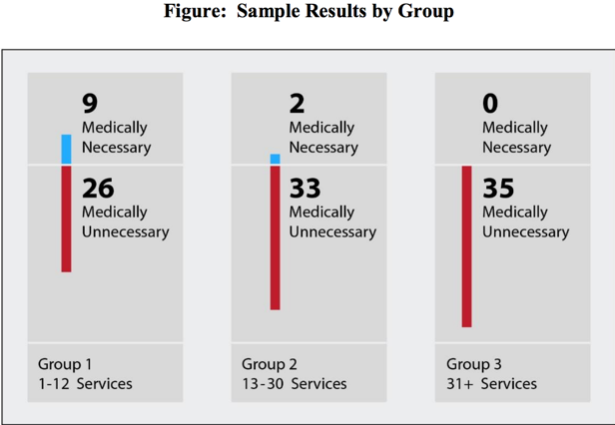

What Was Found
The chiropractors submitted claims for all 105 services with the AT modifier and initial treatment date, indicating that the services were for active/corrective treatment for subluxation and all documentation required by Medicare was being maintained on file.
However, the documentation provided by the chiropractors for 94 services did not support the medical necessity of the services;
On the basis of our sample results, we estimated that $358.8 million, or approximately 82 percent, of the $438.1 million paid by Medicare for chiropractic services was unallowable.
These overpayments occurred because CMS’s controls requiring chiropractors to include the AT modifier and initial treatment date on claims were not effective in preventing payments for medically unnecessary chiropractic services.
Our claim data analysis and audit results suggest that chiropractors submitted claims with the AT modifier regardless of whether the services were for active/corrective treatment for subluxation.

