GROIN

Pain in the groin, medial thigh, and pubic area can be caused by:
- Pubic symphysis instability
- Osteitis pubis
- Pubic ramus stress fracture
- Femoral neck stress fracture - pain in the groin is the earliest and most frequent sign of a femoral neck stress fracture
- Adductor tendonitis

raettcatuchsmfeemntons /

\, ;:\..:t:.'.-----'·· ,i
. . .· :': rOorsatovoaasrclhunlat1rs

Avulsion of te 1G1
,
. , ..

\',,.._·· necrosis of the
femoral epiphysis Q.'· . .. ; -·
Slipped capital ' . , .· femoral head
('--' . ', / •• l [ \j y fl;?' /
\ s,, metis )
1 | adductor group | pubis !
\ | attachment | / /

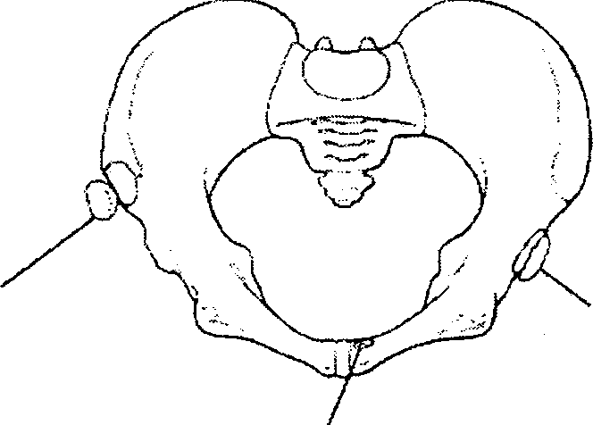
Anterior superior ili".lc spine avulsion
Anterior inferior iliac spine avulsion

Strain of the rectus abdominis attachment

TABLE 2. Physical Examination of the Inguinal Region

Patient's Position Procedure
Details

Standing
Observe posture. gait, limp. alignment, muscle wasting, ability to sit and stand up
• Have the patient point to the area of pain and the pattern of radiation
• Have the patient reproduce painful movements

Examine the low back: active ROM Forward flexion, side bending, extension

Examine the hip: active ROM

Examine for hernia

Supine Examine the abdomen

Examine male genitalia

Pelvic exam in women. if appropriate

Examine low back, sciatic nerve roots

Examine hip motion

Palpate pelvic structures Examine sacroiliac joints

Look for leg-length discrepancy

Prone Examine hip motion

Side lying Examine iliotibial band

Sitting Evaluate muscle strength

Test reflexes Test sensation
Trendelenburg's sign (hip adductor strength), ability to squat and duck walk

Palpate the inguinal region (have the patient cough or strain down)

•Palpate for abdominal aortic aneurysm. pain, rebound, guarding. hernia, pulses, nodes
•Test for costovertebral angle tenderness (renal punch)
•When appropriate, perform a rectal exam to palpate the prostate and rule out occult blood

Palpate for a testicular mass. varicocele. or tender epididymis

•Look for purulent vaginal discharge of pelvic inflammatory disease and bluish cervix of pregnancy (ectopic)
/
• Palpate for tender cervix or adnexa, ovarian mass

Perform straight-leg raise test. test for Lasegue's sign and Bragard's sign (dorsiflexion of ankle)

• Evaluate flexlon. external rotation. internal rotation. abduction, adduction, joint play, quadrant tests
•Perform passive straight-leg raise, Thomas, and rectos femoris stretch tests

Palpate symphysis, pubic rami. iliac crests. adductor insertions, ASIS, PSIS. ischlal tuberosities

Perform Patrick's {FABERE) test

Verify grossly and determine true length by measuring from ASIS to lateral malleoli

• Evaluate extension as well as internal and external rotation
• Perform Ely's and femoral nerve stretch test Perform Ober's test
Test hip flexion {l-2, L-3}, hip extension (l-5. S-1, S-2). abduction (l-4. L-5. S-1), ad<Juction (L-3. L-4)

Assess patellar tendon (l-4)

Assess lower abdomen (T-12), groin (l-1), medial thigh (L-2). anterior quadriceps (L-3)

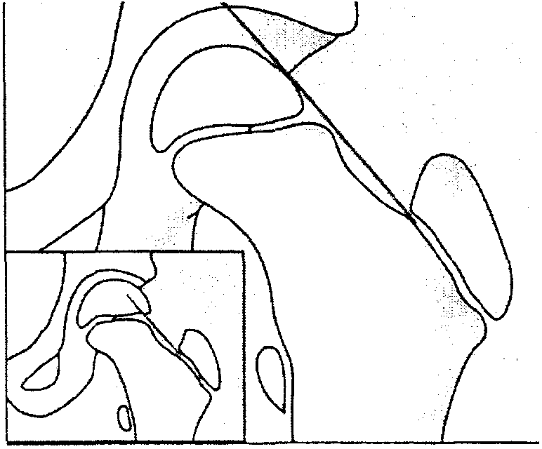
Pain can be referred to the groin by these conditions:
  - Inguinal or femoral hernia
  - Inflammation or infection of the abdominal organs (appendicitis, urinary tract infection, crohn's disease)
  - Gynecological or urinary infection or disease (prostatitis, ovarian cyst, ureteral dysfunction)
  - Tumors, osteoma, metastatic disease of the femur or lower pelvis
  - Sickle cell anemia that causes femoral head avascular necrosis
  - Enlarged lymph glands in the femoral triangle area (infection, Hodgkin's disease)
  - Circulatory problems of the femoral artery (arteriosclerosis)
  - lliopsoas abscess
  - Tubercular disease of the hip

Pain in the groin, medial thigh, hip, or knee in the adolescent can be due to a slipped capital femoral epiphysis. In the 4-6 yr old, this pain can be caused by Legg-Calve-Perthes disease, which is an articular osteochondrosis of the entire secondary ossification center of the femoral head.
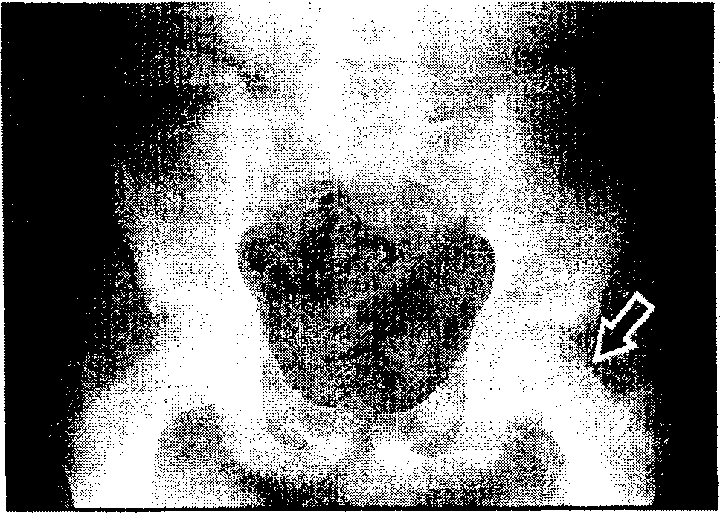
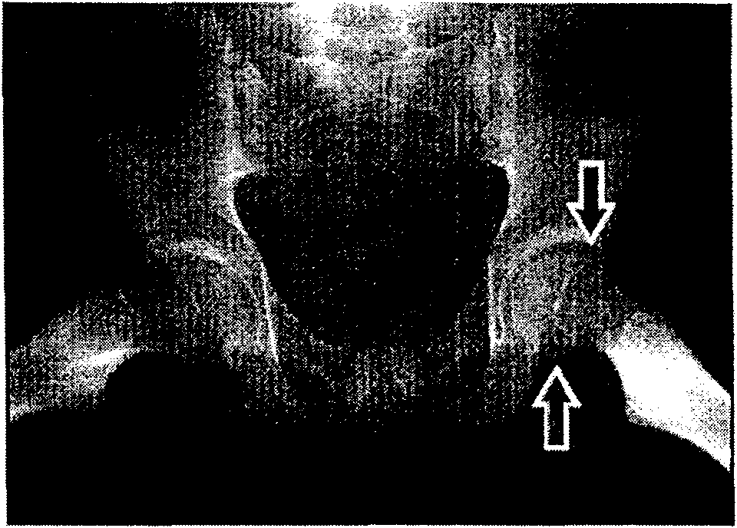
/

Important causes of chronic groin pain include:
- Muscle and tendon lesions
- lliopsoas bursitis
- Osteitis pubis
- Stress fractures of the femoral neck and pubic rami
- Sacroiliac joint and hip joint disorders
- L1/2 or L2/3 disc herniations
- Occult inguinal or femoral hernia

Common acute groin injuries include injuries to the adductor longus, rectus femoris, sartorius and iliopsoas muscles and their tendons. Groin injuries are common in soccer and jumping sports. The sites of pain and local tenderness, as well as pain on resisted stress or stretching, are important in determining injury to the rectus femoris, iliopsoas and adductors. Limitation of hip movement due to hip disease, and referred pain, due to spinal disorders, must be kept in mind.

Three conditions associated with chronic overload of the adductor muscles are:
  - Pubic stress symphysitis (osteitis pubis)
  - Pubic stress fracture (avulsion stress fracture of the pubic bone) /
  - Adductor insertion avulsion syndrome

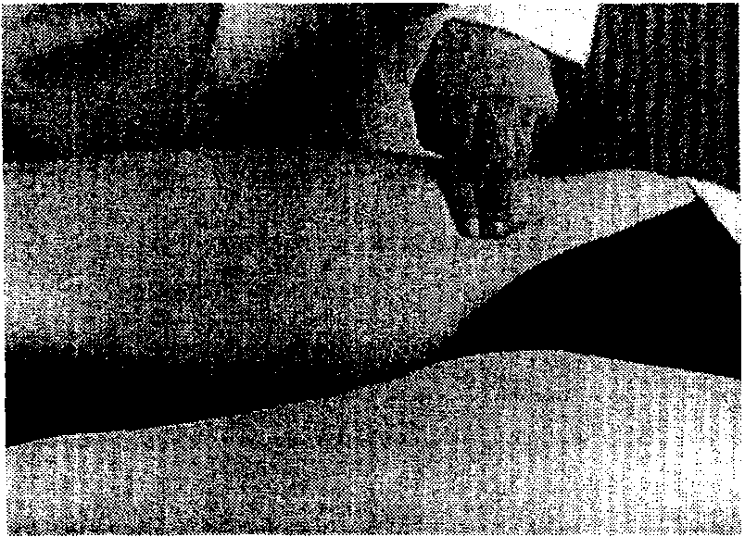
Palpation of the hip joint. The acetabulum and the hip joint are located about 2 cm lateral and 2 cm inferior to the point where the femoral pulse is palpable. Although the hip joint cannot be felt, the finding of tenderness at this location suggests that the patient's pain is due to hip joint pathology.

$evere osteoarthritis of both hips

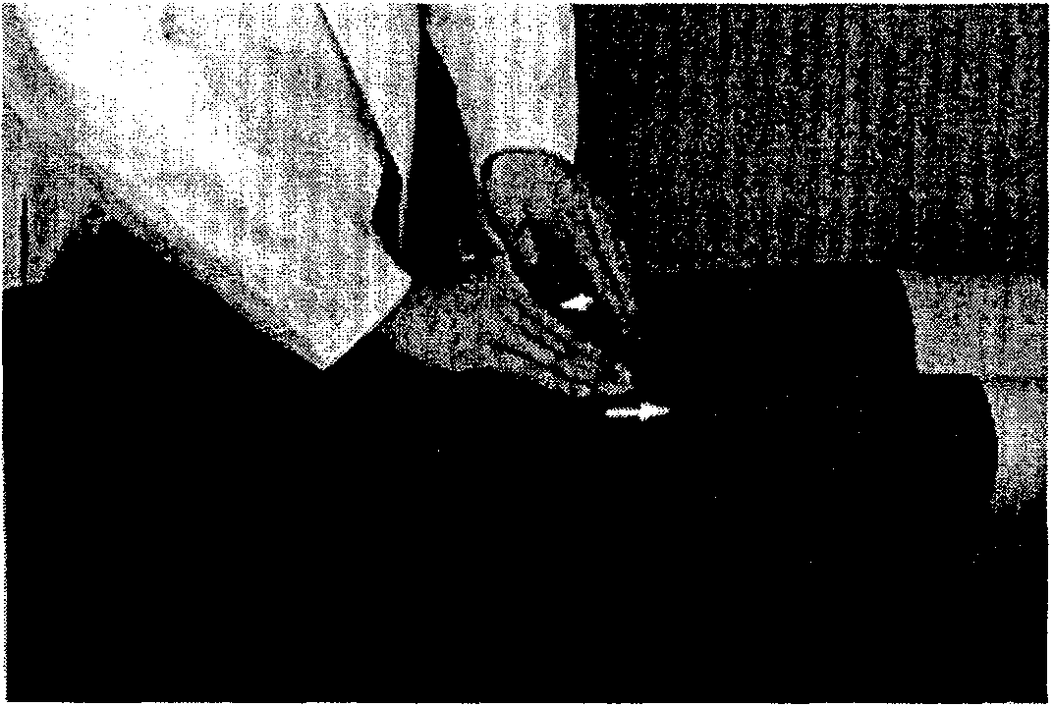
Symphysitis, or symphysis instability, must be excluded as a cause of groin pain, particularly if there are bilateral groin and lower abdominal symptoms. Pubic stress symphysitis usually has an insidious onset with acute exacerbations during stressful sports activity. Examination reveals focal tenderness of the pubic symphysis bilaterally and pain on abduction and extension of the thighs. Radiographic evidence of sclerosis and irregularity of the pubic bones at the symphysis, and a hot spot at the symphysis on bone scan are confirmatory findings.

Pubic symphysis stress test designed to detect instability or pain associated with an injured or inflamed pubic symphysis.

I

Symphysitis or instability of the symphysis pubis

A pubic stress fracture will cause groin pain aggravated by running. The diagnosis can be confirmed by x-ray or bone scan.

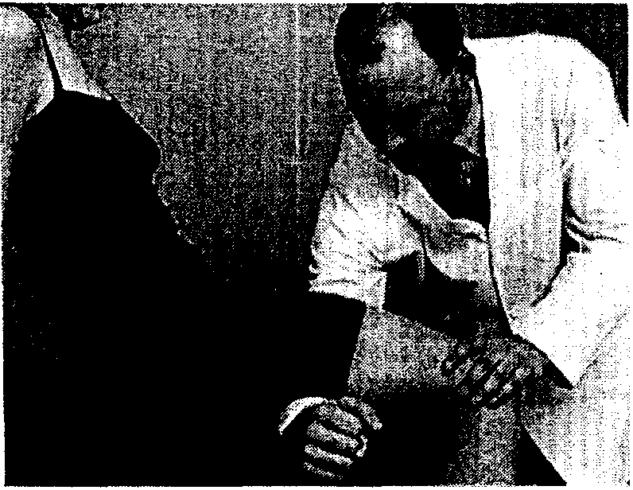
The fulcrum test helps in the detection of stress fractures of the femoral shaft.
Performed with the patient seated at the side of the examination table. The examiner places one forearm beneath the middle of the patient's thigh to serve as a fulcrum and then presses down on the knee. If this is painful, a stress fracture of the femoral shaft should be suspected.

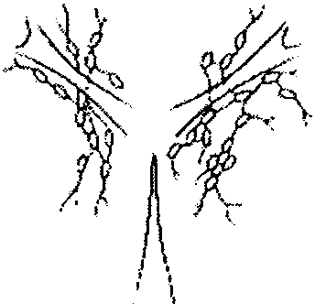
Lumps in the groin can be due to hernia, lipoma, lymph nodes or psoas abscess.

Lymph nodes in the groin area

Only the superficial lymph nodes are accessible to physical examination.

Adductor insertion avulsion syndrome causes pain and tenderness localized to the region of muscular attachment, aching in character, increased by activity and relieved by rest.

The external inguinal ring is a triangular slit-like structure palpable just above and
lateral to the pubic tubercle. The inguinal canal forms a passage through the )
abdominal wall. Its internal ring is about 1 cm above the midpoint of the inguinal ligament, between pubic tubercle and the ASIS. Neither the canal nor internal ring are palpable through the abdominal wall. Through the inguinal canal passes the vas deferens on its way into the abdominal cavity toward the seminal vesicle.

llfi;.j_
The femoral canal is not identifiable but its location is important since
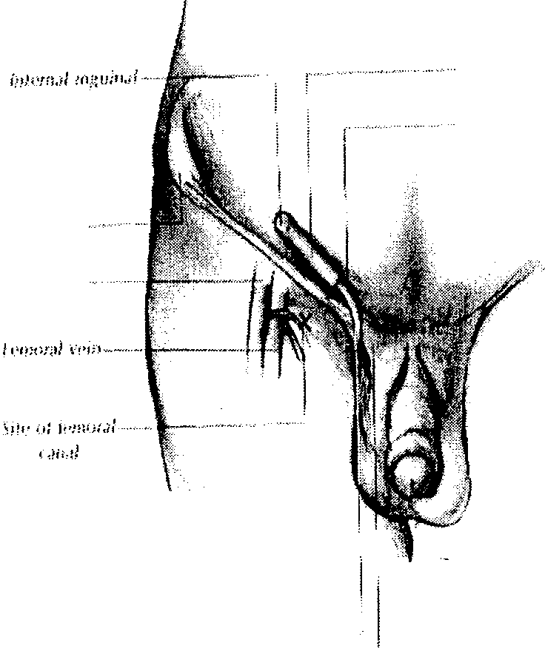
1 ';"""" "'H";,,,,; femoral hernias
1mg

may protrude here.
It is a potential space medial to the femoral artery, below the inguinal ligament, and lateral to the pubic tubercle. Its location can be estimated by placing your right index finger on the patient's right
,,,.,,", ,,,1., ..1i - - ··· femoral artery.
Your middle finger will then overlie the femoral vein, your ring finger, the femoral canal.

PALPATION

Using in turn yo u r 1·igh l h a nd for Uw potien t 's righ t :-i id n nnd you r left h nnd for the pa tien t's left side, in vagi n u t e lomrn sc1·olnl t:1ki n w i t h you r i ncfox finger. St.ir t n t n poi n t low enough to nmmre full m obiJ ily of you r finger.
This ma y be th e bottom of the scro­ tnl sac. Follow the spcrmalic cord u pward to t h e triangula r sli t-like opening of the extcmal inguinal ri ng. This is just above and la teral to

the pubic tu bercle. If the ring is some\·vha t enla rged, it may admit

\
). A n r r•rior \tf f H'U• Jt
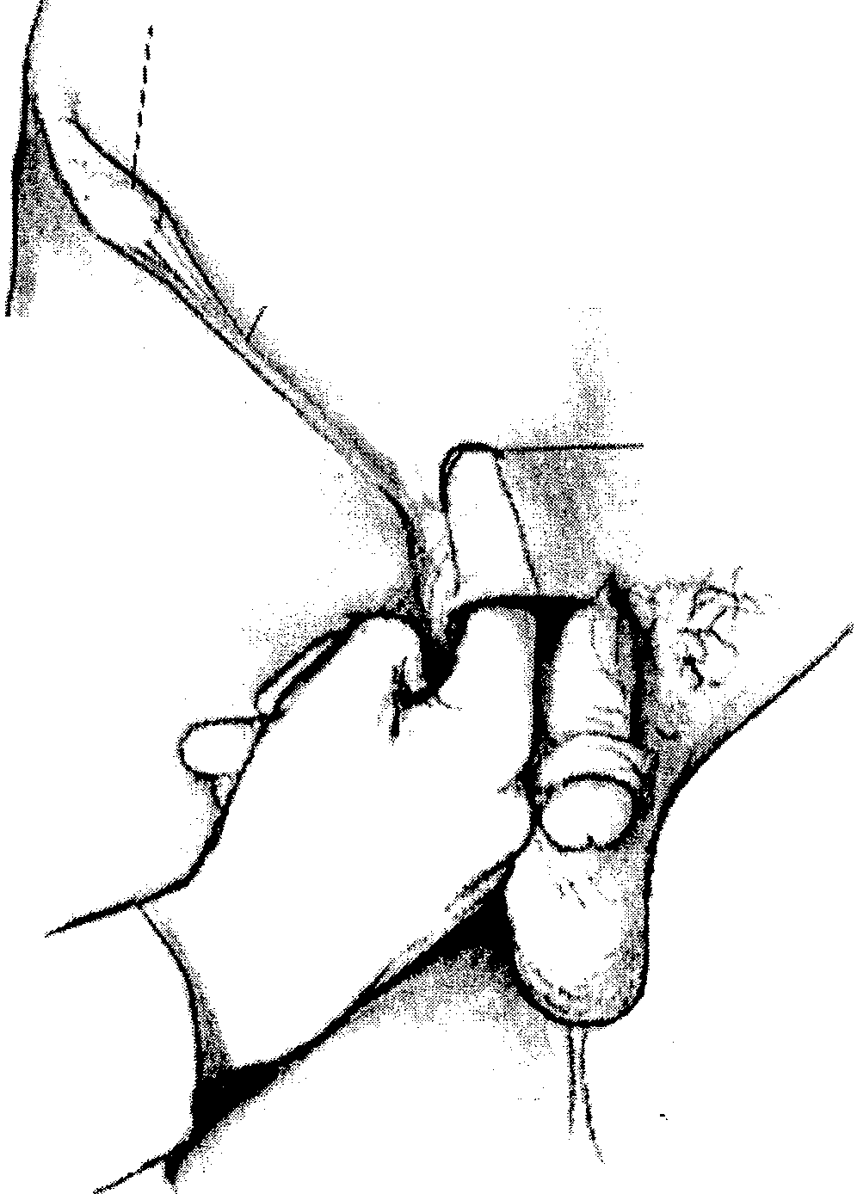
'1pi1w

lmgv i n.1 (
/'1i·g;.wwnl
; J
your index finger. If possi ble, gently follow the i nguina l ca nal la te rally in its oblique course. WHh your finger loca ted oither a t the external ring or within the murnl. ask the pa tient to strain down. Note nny palpable 11ernia ting mass us it touches your finger.

··--··-"-··-···•·•·· ·• J \f l' m.11 ing1m1,1I
I
ti!!.r.!

\
\

Palpa te tho u n tt rior thigh in the region of the femoral canal. Ask the pn tien t to strain d mvn agai n. Notu n ny S\'•lelling or tenderness.

Conjoint tendon injury of the inguinal ring should be considered, even in the absence of a defined hernia, when there is localized tenderness with cough­ induced pain, at the external ring and internal ring, and an absence of localizing features of adductor tendon injury or symphysitis.

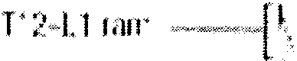
I
I
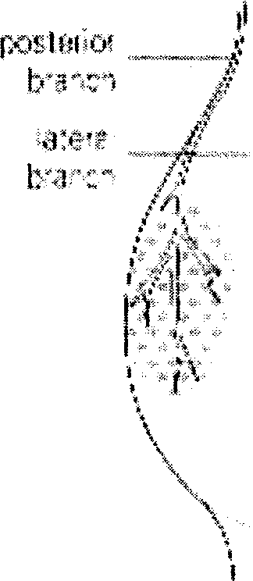
'•
Referral of pain to the skin
overlying the inguinal area can be
I due to mechanical disorders of
i

I .
,;:- _.,., .-l {1fl!(* IC''
the T12-L 1 area. Pain on

··>-,', ·:.#)t.'
. \\d
.
(/
l
l
I
l

I I I I
l
t.:.-.··,..
'")
b
palpation and mobilization of the
spinous processes of the lower thoracic and upper lumbar vertebrae may point the examiner to the correct origin.
/

Patterns of referred pain from experimental injection of interspinous tissues at the L1 and L2 segments can occur in the loin and also in the groin. Lesions in the upper lumbar vertebrae will often refer pain into the anterior aspect of the thigh.

The obturator and genitofemoral nerves may cause pain or tingling in the groin or in the medial thigh when they become entrapped. Extension of the thigh increases the pain. Entrapment of the genitofemoral nerve is often caused by excessively tight clothing over the inguinal ligament. Patients with entrapment of this nerve experience pain and/or numbness in an elliptical area on the anterior aspect of the thigh immediately below.the middle of the inguinal ligament. This . area also shows decreased perception of pinprick and touch.

Nerve root compression from L2 to L4 may mimic hip disease by causing referred pain in the inguinal area and the anterior aspect of the thigh. In these cases, neurologic deficits and a positive femoral nerve stretch test in the absence of pain or limitation of motion of the hip should evoke the diagnosis.

Cox states that in a series of patients radiation to the groin was reported in 3 out of 11, two with compression of the L5 ganglion and one with compression of both the L5 and S1 ganglia. All 11 patients underwent surgical decompression.

Adductor tendon injury is characterized by groin pain when sprinting, pivoting or kicking. There is tenderness in the gracilis and adductor brevis, close to the insertion, with pain on resisted adduction and on abduction stretch.

Lewit associates trigger point involvement of the adductor muscle group with articular dysfunction of the hip joint.

Palpation of the adduct9r longus

I

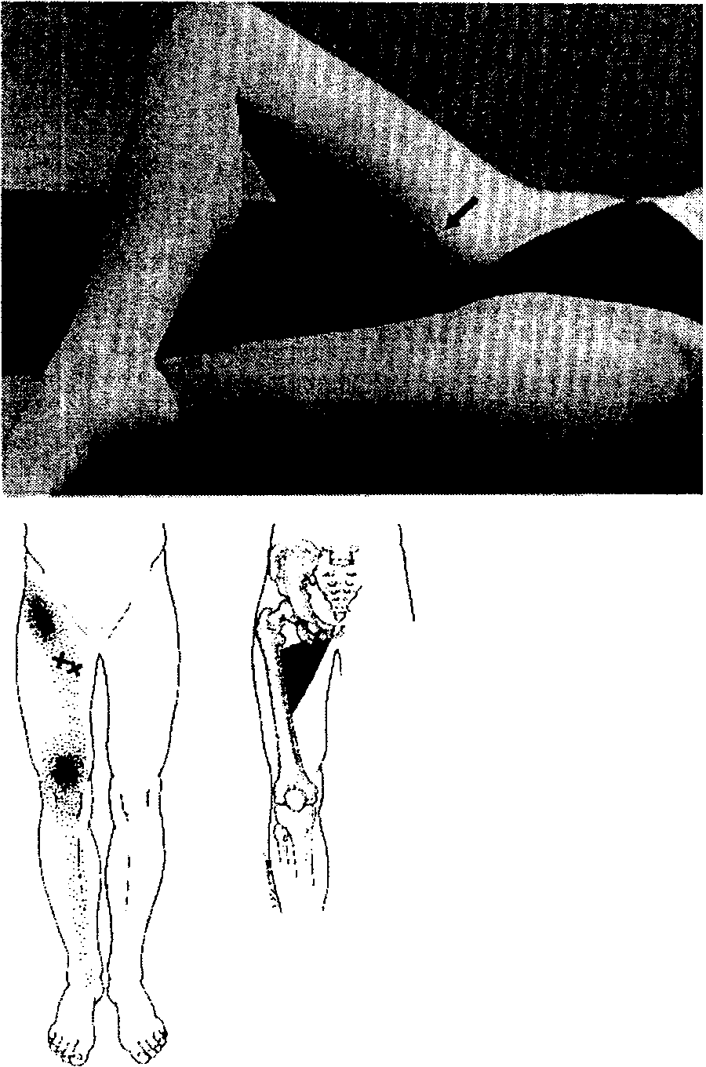
Figure-four position brings out the contour of the adductor longus.

The adductor longus and brevis trigger points project pain to the groin and in the anteromedial portion of the upper thigh.

Tenderness of the tendinous attachment of the adductor magnus is elicited by pressure on the posteromedial aspect of the medial femoral condyle. Tenderness here is usually due to active or latent trigger points in the adductor magnus.

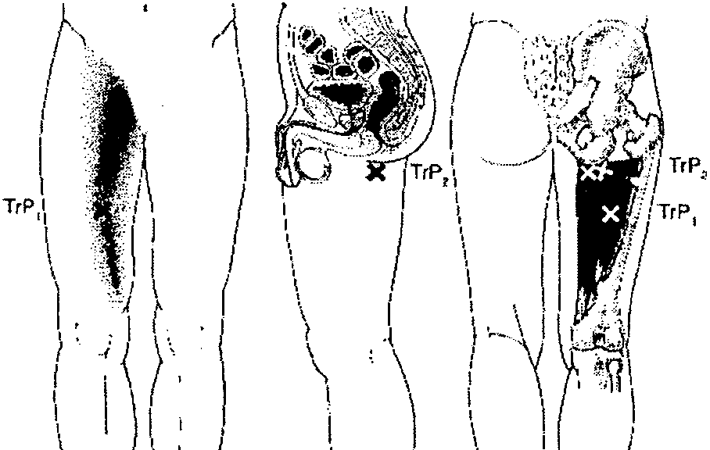
The trigger point in the midportion of the adductor magnus muscle refers pain upward into the groin below the inguinal ligament and downward over the anteromedial aspect of the thigh nearly to the knee. The groin
pain is described as deep, almost as if it might be in the pelvis, but the patient is unable to identify pain in any specific pelvic structure.

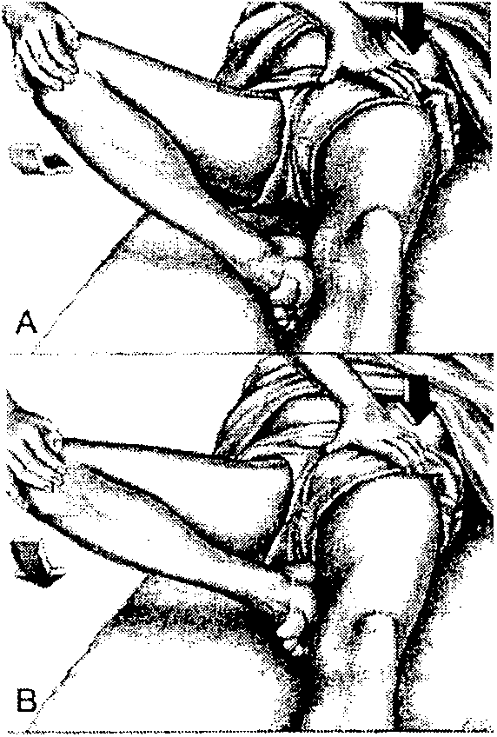
Testing stretch range of the adductor group of muscles.
I

A - position of restricted movement. Foot is at side of knee.

B - essentially full range of motion. The thigh has been flexed additionally by moving the foot farther up the thigh to include testing of the ischiocondylar part of the adductor magnus.

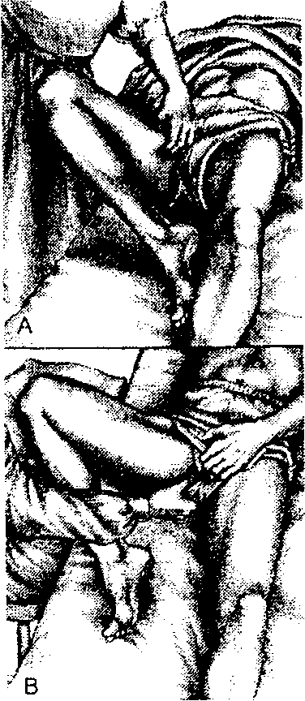
A - examination for trigger points in the adductor longus and brevis by pincer palpation.

B - palpation of the proximal end of the adductor magnus examined by flat palpation against the underlying ischium posterior to the adductor longus, adductor brevis, and gracilis muscles.

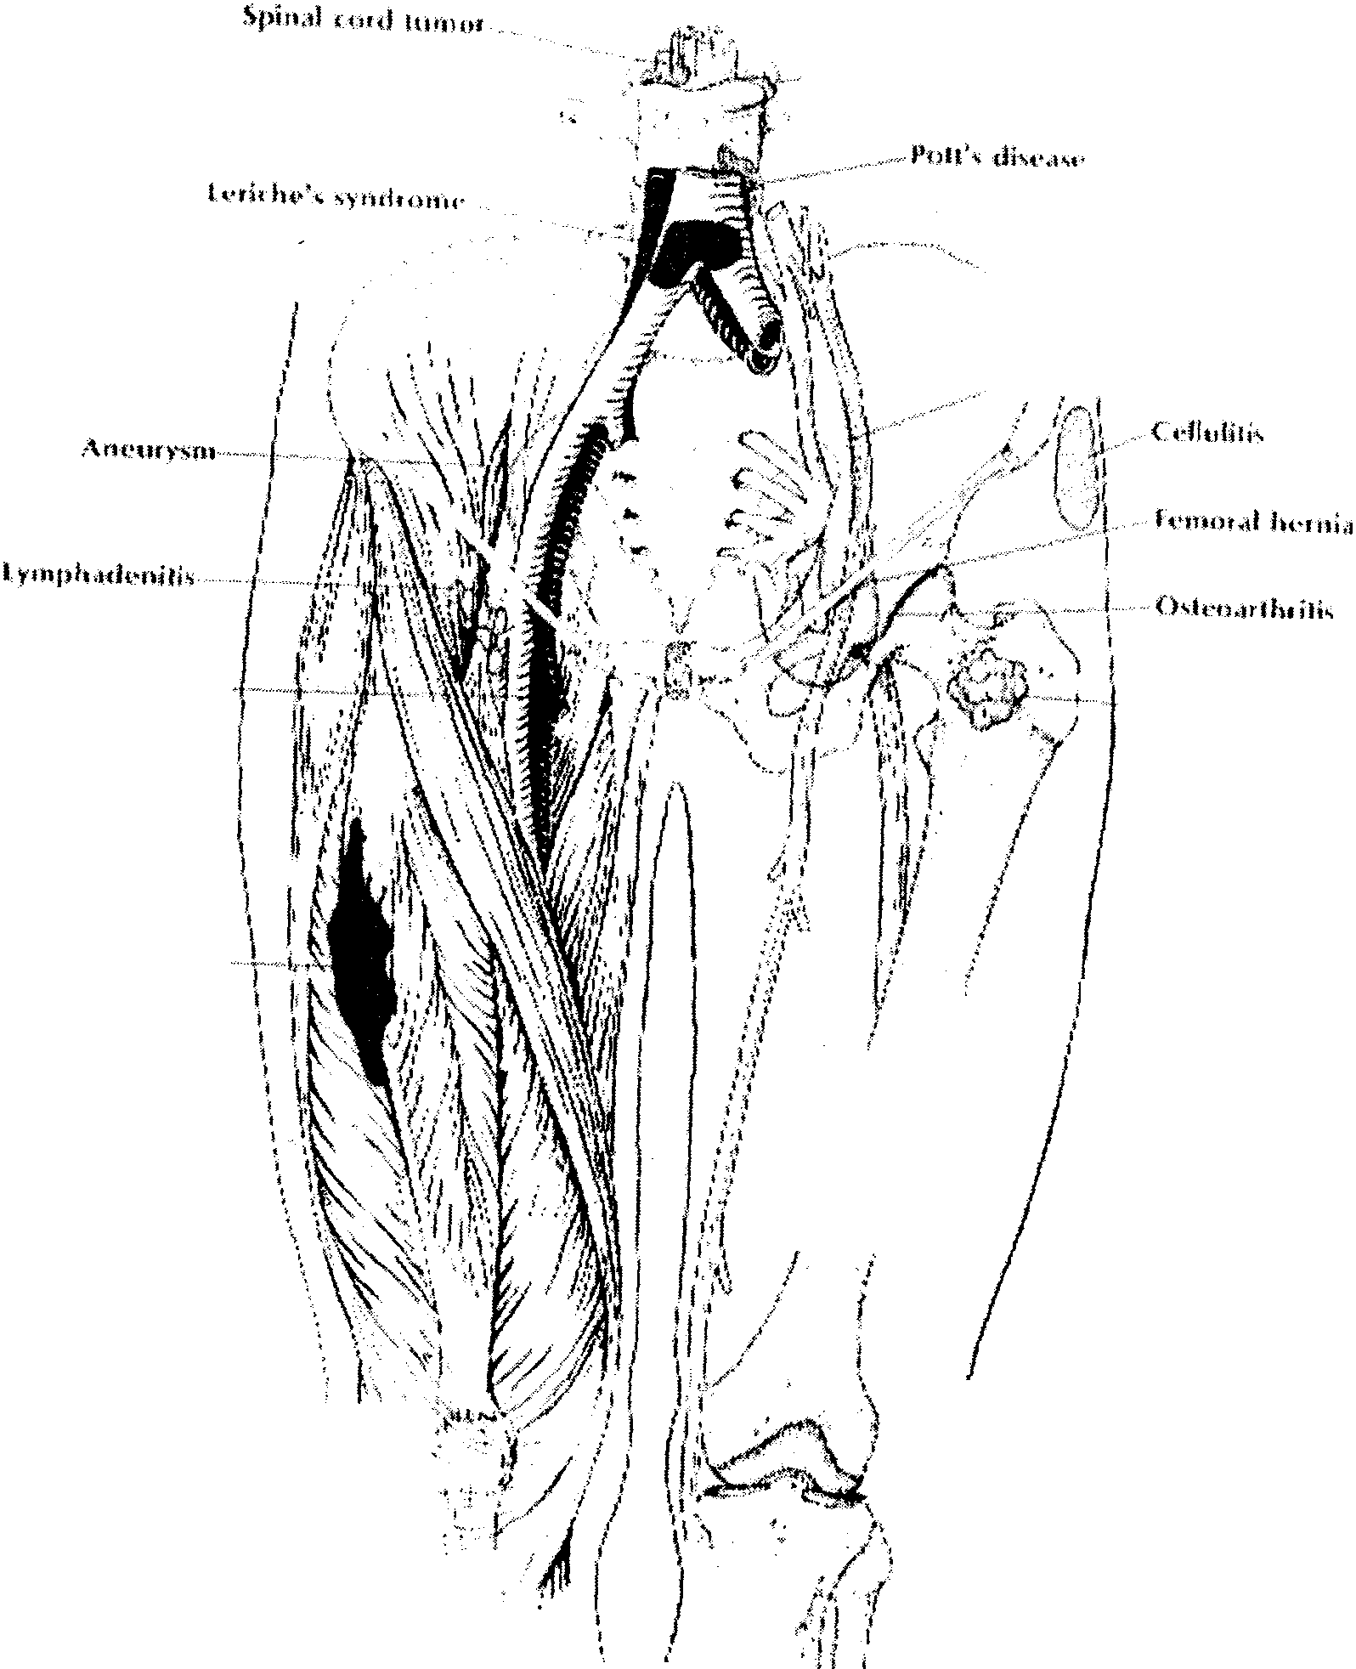
. .,

,.-.··

Ihmmhophfohili-,; ···
Prim.ir>t or
·m•·t.1-i..ti< lumor'

/
I
i
1
/
}
'

/
/ ...i
'
/
I
I

'
.
\ 1 '-,

·, I
I •J

\\ ',
I
'

Differential diagnosis of groin pain

Section 18 Page 13

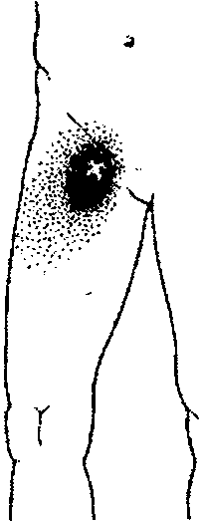
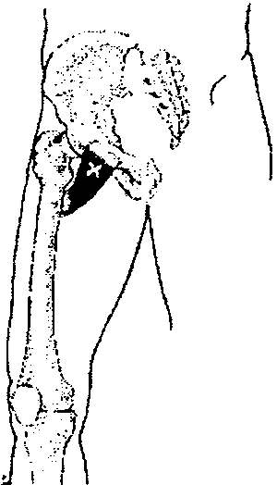
Pectineus muscle and trigger point. The trigger
( point produces a deep-seated aching pain in the groin immediately distal to the inguinal ligament;
the pain may also cover the upper part of the anteromedial aspect of the thigh. Pain occurs especially during weight-bearing activities that cause abduction of the thigh.
\ r
I

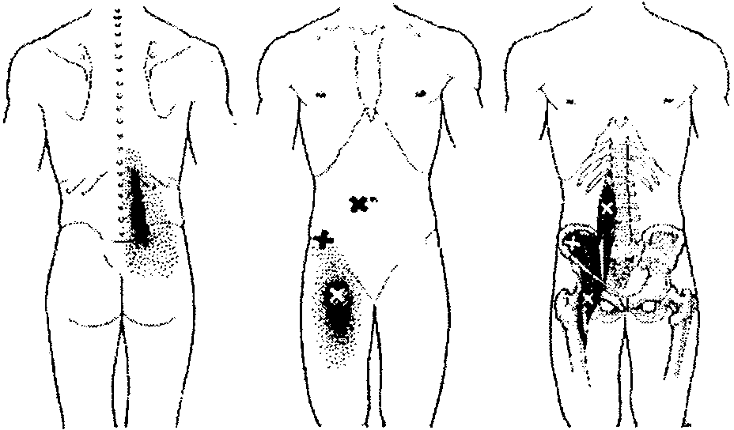
Palpation of trigger points near the attachment of the iliopsoas muscle (mostly iliacus fibers) on the lesser trochanter of the femur may refer pain both to the back and anteriorly to the thigh.

I

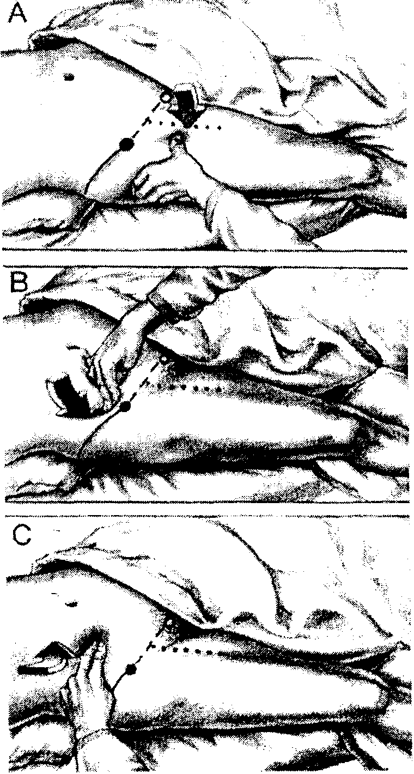
Palpation of trigger points in the iliopsoas muscle at three locations. The arrows indicate the direction of pressure. The solid circle covers the ASIS. The open circle marks the pubic tubercle. The solid line
marks the iliac crest. The dashed line locates the inguinal ligament. The dotted line follows the course of the femoral artery.

A - palpation of the distal iliopsoas trigger point just above the distal attachment of the muscle to the lesser trochanter.

B - palpation of the iliacus trigger points inside the brim of the pelvis behind the ASIS.

C - digital compression on the proximal psoas trigger points applied first downward beside, and then medially, beneath, the rectus abdominis muscle toward the psoas muscle.

Section 18 Page12

References

Mazieres B, Carette S. The Hip. In: Klipprl JH, Dieppe PA, Ed. Rheumatology, 2nd Edition. Mosby, London; 1998: 10.6-10.7.
Travel! JG, Simons DG. Myofascial Pain and Dysfunction. The Trigger Point Manual. Williams & Wilkins, Baltimore; 1992: 90, 100, 291, 292, 303.
Bates B. A Guide to Physical Examination. J.B. Lippincott Company, Philadelphia; 1874: 182, 186, 187.
Lacroix VJ. A complete guide to groin pain. The Physician and Sportsmedicine 2000; 28: 66-86.

I

Section 18 Page14

