Documentation –
What is necessary, what isn’t and why
By Brad Hayes, D.C.

Chiropractic Documentation
The purpose of this class is to clarify and simplify Documentation
On the whole, chiropractors do a poor job of documentation
2005 OIG Report on Chiropractic
CHIROPRACTIC SERVICES IN THE MEDICARE PROGRAM: PAYMENT VULNERABILITY ANALYSIS
CHIROPRACTIC SERVICES IN THE MEDICARE PROGRAM: PAYMENT VULNERABILITY ANALYSIS (2005)
Overall error rate of 67 percent, ($285 million in improper payments)

Maintenance services were the most common type of noncovered chiropractic services that Medicare paid for in 2001. (Majority - $186 million)
Medically unnecessary for other reasons. (14 percent -$65 million)
Services billed with a spinal manipulation code that were actually extraspinal manipulations or non-manipulative treatment, such as massage. ($24 million)
upcoding was also a significant problem, (resulting in a $15 million overpayment)
2009 – OIG REPORT - INAPPROPRIATE MEDICARE PAYMENTS FOR CHIROPRACTIC SERVICES
In the report, the OIG examined 2006 chiropractic claims for beneficiaries receiving more than 12 services from the same chiropractor. The objective of the review was to determine the extent to which:
Such services were appropriate.
Controls ensured that chiropractic claims were not for maintenance therapy.
Claims data can be used to identify maintenance therapy.
Chiropractic claims were documented as required.

2009 – OIG REPORT - INAPPROPRIATE MEDICARE PAYMENTS FOR CHIROPRACTIC SERVICES
According to the report, the OIG found that:
Medicare inappropriately paid $178 million for chiropractic claims in 2006, representing 47 percent of claims meeting the OIG's study criteria.
Efforts to stop payments for maintenance therapy have been largely ineffective.
Claims data lacks initial visit dates for treatment episodes, hindering the identification of
maintenance therapy.
• Chiropractors often do not comply with the Medicare Benefit Policy Manual documentation requirements.

White House Executive Order
By the authority vested in me as President by the Constitution and the laws of the United States of America, and in the interest of reducing payment errors and eliminating waste, fraud, and abuse in Federal programs, it is hereby ordered as follows:
CMS Teleconference on C.E.R.T. June 15, 2010
During that teleconference it was revealed that as a result of Executive Order 13520 Signed by President Obama on November 20, 2009, four services in Medicare Fee-for-Service would be targeted for special review;

Power Wheelchairs,
Inpatient Hospital Short Stays,
Pressure Reducing Support Surfaces and
Chiropractic Services

October 2016 OIG Report
For calendar year (CY) 2013, Medicare Part B paid approximately $439 million for chiropractic services provided to Medicare beneficiaries nationwide.
A 2005 Office of Inspector General (OIG) evaluation found that as chiropractic care for a beneficiary extended beyond 12 treatments in a year, it became increasingly likely that individual services were medically unnecessary, with an even greater likelihood that services were medically unnecessary after 24 treatments.
In addition, four more recent OIG reviews of individual chiropractors (with reports issued between 2013 and 2016) found that Medicare made improper payments for chiropractic services that were medically unnecessary, incorrectly coded, insufficiently documented, or not documented.
We conducted this review to determine whether these issues occurred nationwide. Our objective was to determine whether Medicare payments for chiropractic services complied with Medicare requirements.
What Was Found
Most Medicare payments for chiropractic services did not comply with Medicare requirements.
Of the 105 sampled chiropractic services,
11 were allowable in accordance with requirements.
However, the remaining 94 services were not allowable because they were medically unnecessary.
As a result, the chiropractors who billed for these services received $2,447 in unallowable Medicare payments.
The figure below shows the number of medically necessary and medically unnecessary services by group. The number of medically unnecessary services was higher in group 2 than in group 1. All of the services in group 3 were medically unnecessary.

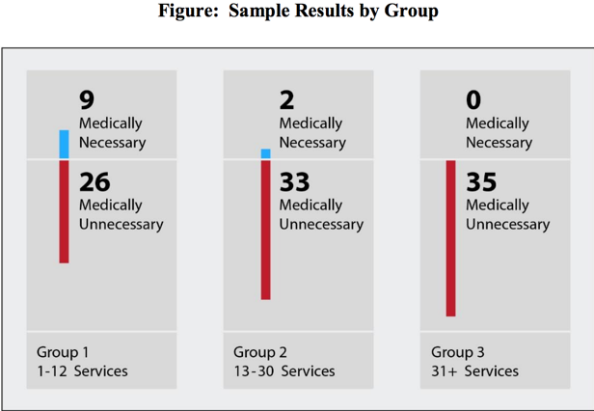

What Was Found
The chiropractors submitted claims for all 105 services with the AT modifier and initial treatment date, indicating that the services were for active/corrective treatment for subluxation and all documentation required by Medicare was being maintained on file.
However, the documentation provided by the chiropractors for 94 services did not support the medical necessity of the services;
On the basis of our sample results, we estimated that $358.8 million, or approximately 82 percent, of the $438.1 million paid by Medicare for chiropractic services was unallowable.
These overpayments occurred because CMS’s controls requiring chiropractors to include the AT modifier and initial treatment date on claims were not effective in preventing payments for medically unnecessary chiropractic services.
Our claim data analysis and audit results suggest that chiropractors submitted claims with the AT modifier regardless of whether the services were for active/corrective treatment for subluxation.
Why is Documentation Necessary?
Improves continuity of care
Other providers can understand what you did and why you did it
Establishes qualification for reimbursement
It helps avoid malpractice
Establishes the quality of care
How To Document a Case Properly
The most common system of documentation is SOAP
Which is fine for the purposes of Evaluation and Management
However, day to day notes do not fit that format as well
Problem Oriented Medical Records is another widely adopted system.
Critical Elements of Good Records:
They must be readable, easy to navigate and follow a logical sequence
They must be clear and simple to follow
They must have all necessary components
They must demonstrate clinical thought processes
They must follow evidenced based guidelines where they are established.
CCGPP
ODG
ACOEM
NGC
Milliman & Robertson
Individual Carrier Guidelines

Strategies to Insure Records are Readable
Dictation
Pre-printed note choices
Electronic Medical Records

What Doesn’t Work?
Hand written notes
Are not reliable for being able to read
Travel cards
Are usually coded, and difficult to interpret
Some computerized notes are nothing more that cut and pasted replicas of the previous notes

The Future – Electronic Medical Records
More than 80 percent of docs use EHRs
Counting only certified EHR adoption, however, that rate goes down to 74 percent. Also, 51 percent of doctors are using only basic EHR functionalities, according to ONC.
The function used by most physicians – 86 percent – is recording patient demographic information. Moreover:
Six in 10 physicians reported having the capability to view imaging results. ONCdid not report on how many doctors use the function.
More than 8 in 10 physicians reported their EHRs allowed them to use computerized prescription order entry, record clinical notes, patient's medications, allergies, and problem lists, and view laboratory results.

The Future – Electronic Medical Records
Primary care physicians are the most likely to employ EHRs.
Primary care physicians had the highest rate of adoption of certified EHRs at 79 percent.
More than half – 56 percent – of primary care physicians were using all basic EHR functionalities. Fewer than half of medical and surgical specialists reported using all basic EHR functionalities.

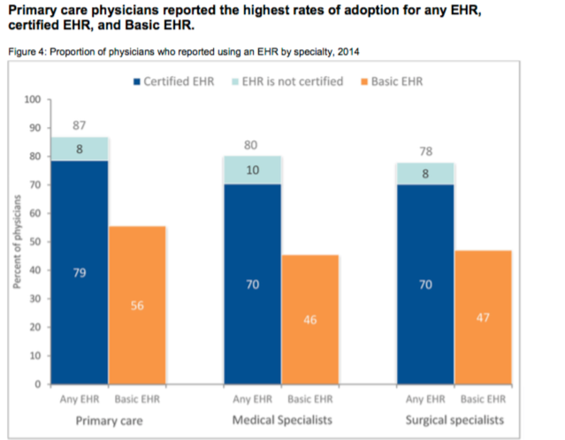
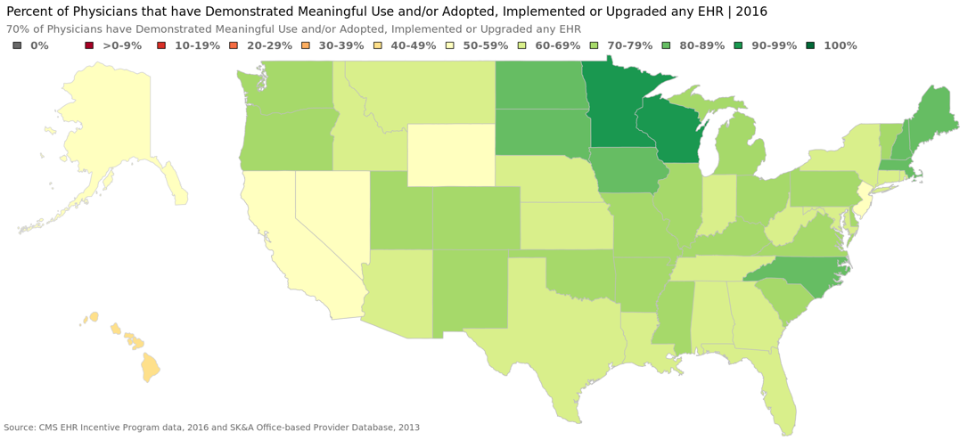

Constructing Good Medical Records
Doctor must have a good understanding of each component of the medical record.
Why it is there
What makes up the component?
How to successively establish the component
A look at the components
Subjective –
Initial – the patient’s perception of their condition, usually recorded in their own words. (History)
Follow-up – the perception of the patient’s response to care
How is the patient responding to care
Better, same or worse or some variation
For each complaint
Subjective
Medicare –
1. History
Review of chief complaint;
The patient’s perception of their complaint and the progress of the complaint in relation to treatment
Changes since last visit;
Patient’s perception of change since last visit
Better, same or worse and how if appropriate
System review if relevant.
A systems review is usually relevant with a new condition or an exacerbation

Objective
Objective -
Objective means you observe the finding through your own senses. Generally this is based on examination, but can be based on observation such as a scar, or testing results.
Medicare Requirements
2. Physical exam
Exam of area of spine involved in diagnosis (PART);
Assessment of change in patient condition since last visit;
Evaluation of treatment effectiveness.
Assessment
Medicare
Assessment of change in patient condition since last visit;
The patient’s condition has improved
Significantly
Somewhat
The patient’s condition improved but has returned to previous status
The condition is the same
The patient’s condition has worsened
Evaluation of treatment effectiveness.
The condition is improving with treatment
The condition is remaining the same
The condition is worsening with treatment
Plan
Documentation of Treatment - What was treated, where it was treated and how it was treated (length of treatment, technique of treatment, location of treatment.)
The patients next recommended treatment
Follow treatment plan
Dismissal
PRN
Medicare
3. Documentation of treatment given on day of visit.
Specifically, the segments treated
Should coordinate with the PART exam

Often Missed Critical Elements From CCGPP
Complicating factors that can prolong care
Related musculoskeletal disorders
Personal
Age (older)5, 6, 8
Sex (female) 5, 6
Severity of symptoms 5, 6
Leg pain > back pain12
Increased spine flexibility 12
Reduced muscle endurance 11, 12
Prior recent injury (<6 mo) including surgery5, 6, 7, 13, 14, 15, 20, 24, 25
Prior surgery15, 16
Asymmetric atrophy of multifidus up to 5 y later17, 18
Abnormal joint motion with or without abnormal electromyogram function of medial spine extensors19

Complicating Factors
Personal
Poor body mechanics
Falling as mechanism of prior injury 20,24
Biomechanical
Prolonged static posture >20° (odds ratio, 5.9) 21
Poor spinal motor control 22
Vehicle operation >2 h per day23
Sustained (frequent/continuous trunk load >20 lb 23
Materials handling (static work postures, frequent bending and twisting, lifting demands, pushing, pulling and repetitive exertion) 24

Complicating Factors
•Psychosocial
Condition chronicity
Employment history (<5 y, same employer) 5, 6
Employment satisfaction 9
Lower wage employment
Family/relationship stress 9
Attorney retention
Expectations of recovery

Complicating Factors
Caution is necessary in evaluating risk factors. Many patients with significant risk factors respond well and achieve significant clinical improvement. Patients with a significant number of risk factors warrant close observation and quick reaction if treatment response is below expectations.
Evidence for Best Practice? John J. Triano, DC, PhD JMPT, Volume 31, Issue 9, Pages 637-643 (November 2008)
Often Missed Critical Elements From CCGPP

Outcome Instruments
The broad general classes of outcomes include functional outcomes, patient perception outcomes, physiologic outcomes, general health assessments, and subluxation syndrome outcomes.
Examples:
Roland Morris Disability Questionnaire,
Oswestry Disability Questionnaire,
Pain Disability Index,
Neck Disability Index,
Waddell Disability Index, and
Million Disability Questionnaire.
Visual analog scale
Pain diary
McGill Pain Questionnaire
SF-36
Often Missed Critical Elements
Informed Consent
Informed consent is the process of proactive communication between a patient and physician that results in the patient's authorization or agreement to undergo a specific medical intervention. Informed consent should be obtained from the patient, performed within the local and/or regional standards of practice.
Examination Results (including x-ray reports)
Treatment Plans
Case Management
Other Physician Records
Reports
Correspondence, etc.

The 4 Laws of Documentation
The 4 Absolute Laws of Documentation
Documentation Law # 1

Completely understand the definition of each CPT code and ICD code you are using as well as the documentation requirements of the code.
Example:
Cervical Strain - S16.1XXA
Cervical Sprain – S13.4XXA

ICD 10-S16.1XXA Cervical Strain Initial Encounter
The following code(s) above S16.1XXA contain annotation back-references that may be applicable to S16.1XXA:S00-T88
Injury, poisoning and certain other consequences of external causes S10-S19
Injuries to the neck S16
Injury of muscle, fascia and tendon at neck level
Approximate Synonyms
Neck muscle strain
Strain of neck muscle
ICD 10-S16.1XXA Cervical Strain Initial Encounter
A look at the definition and findings of a strain.
ICD 10-S16.1XXA Cervical Strain Initial Encounter

Manual of Acute Orthopaedic Therapeutics
a.First degree (mild strain or slightly pulled muscle)
Etiology is trauma to a portion of the musculotendinous unit from excessive forcible use of stretch.
Symptoms include local pain that is aggravated by movement or by tension of the muscle
Signs of injury include mild spasm, swelling, ecchymosis, local tenderness and a minor loss of function and strength
ICD 10-S16.1XXA Cervical Strain Initial Encounter
The following code(s) above S16.1XXA contain annotation back-references that may be applicable to S16.1XXA:S00-T88
Injury, poisoning and certain other consequences of external causes S10-S19
Injuries to the neck S16
Injury of muscle, fascia and tendon at neck level
Approximate Synonyms
Neck muscle strain
Strain of neck muscle
ICD 10-S16.1XXA Cervical Strain Initial Encounter

Manual of Acute Orthopaedic Therapeutics
Complications include recurrence of the strain, tendinitis, and periostitis at the tendinous attachment site
Pathologic changes cause a low-grade inflammation and some disruption of muscle tendon tissue but no appreciable hemorrhage
ICD 10-S16.1XXA Cervical Strain Initial Encounter

Manual of Acute Orthopaedic Therapeutics
a.Second degree strain (moderate strain or moderately pulled muscle)
Etiology is trauma to a portion of the musculotendinous unit from violent contraction or excessive forcible stretch.
Symptoms and signs include local pain that is aggravated by movement or tension of the muscle, moderate spasm, swelling, ecchymosis, local tenderness, and impaired muscle function.
ICD 10-S16.1XXA Cervical Strain Initial Encounter

Manual of Acute Orthopaedic Therapeutics
Complications include a recurrence of the strain
Pathologic findings consist of the tearing of fibers without complete disruption
ICD 10-S16.1XXA Cervical Strain Initial Encounter

Manual of Acute Orthopaedic Therapeutics
a.Third degree strain (severe strain or severely pulled muscle)
•Symptoms and signs include severe pain and disability, severe spasm, swelling, ecchymosis, hematoma, tenderness, loss of muscle function and usually a palpable defect. An avulsion fracture at a tendinous attachment may mimic a strain.
•Complication is prolonged disability
ICD 10-S16.1XXA Cervical Strain Initial Encounter

Manual of Acute Orthopaedic Therapeutics
•Roentgenograms can demonstrate an avulsion fracture at the tendinous attachment as well as soft tissue swelling.
• Pathology consists of a ruptured muscle or tendon with the resultant separation of muscle from muscle, muscle from tendon or tendon from bone.

ICD 10-S13.4XXA Cervical Sprain Initial Encounter
Sprain of ligaments of cervical spine, initial encounter
2016 2017 2018 Billable/Specific Code
S13.4XXA is a billable/specific ICD-10-CM code that can be used to indicate a diagnosis for reimbursement purposes.
The 2018 edition of ICD-10-CM S13.4XXA became effective on October 1, 2017.
This is the American ICD-10-CM version of S13.4XXA - other international versions of ICD-10 S13.4XXA may differ.
The following code(s) above S13.4XXA contain annotation back-reference that may be applicable to S13.4XXA:S00-T88
Injury, poisoning and certain other consequences of external causes S10-S19
Injuries to the neck S13
Dislocation and sprain of joints and ligaments at neck level S13.4
Sprain of ligaments of cervical spine
Approximate Synonyms
Cervical spine sprain
Sprain or strain of cervical spine
Traumatic torticollis
Whiplash injury of neck
Whiplash injury to neck

ICD 10-S13.4XXA Cervical Sprain Initial Encounter
A look at the definition and findings of a sprain

ICD 10-S13.4XXA Cervical Sprain Initial Encounter

Manual of Acute Orthopaedic Therapeutics
a. First degree sprain (mild sprain)
Signs include mild point tenderness, no abnormal motion, little or no swelling, minimal hemorrhage and minimal functional loss.
Complications include a tendency towards recurrence.
Pathology consists of minor tearing of the ligamentous fibers.
ICD 10-S13.4XXA Cervical Sprain Initial Encounter

Manual of Acute Orthopaedic Therapeutics
b. Second degree sprain (moderate sprain)
Signs include point tenderness, moderate loss of function, slight to moderate abnormal motion, swelling and localized hemorrhage.
Complications can be a tendency toward recurrence, persistent instability and traumatic arthritis.
Pathology is a partial tear of a ligament.
ICD 10-S13.4XXA Cervical Sprain Initial Encounter

Manual of Acute Orthopaedic Therapeutics
c. Third degree sprain (severe sprain)
Signs include a loss of function, marked abnormal motion, possible deformity, tenderness, swelling and hemorrhage.
Complications can be persistent instability and traumatic arthritis.
Stress roentgenograms demonstrate abnormal motion when pain is adequately relieved.
Pathology is a complete tear of a ligament.

The 4 Absolute Laws of Documentation
Documentation Law # 1
Completely understand the definition of each CPT code and ICD code you are using as well as the documentation requirements of the code.
Example: CPT 99204
CPT 99204
99204 - New Patient
Moderate To High Risk Problem
Typical Time 45 minutes
History – Comprehensive
Chief complaint, extended history of problem and complete past-family-social-history and systems review directly related to problems identified in the history
Examination – Comprehensive
General multi-system examination or complete exam of a single organ system
Medical Decision Making – Moderate Complexity
Multiple number of diagnoses, moderate complexity of reviewed data, moderate risk morbidity/mortality
CPT Definitions
Low Severity
A problem where the risk of morbidity without treatment is low; there is little to no risk of mortality without treatment; full recovery without functional impairment is expected.
Moderate Severity
A problem where the risk of morbidity without treatment is moderate; there is moderate risk of mortality without treatment; uncertain prognosis OR increased probability of prolonged functional impairment.
CPT Definitions
High Severity
A problem where the risk of morbidity without treatment is high to extreme; there is a moderate to high risk of mortality without treatment OR high probability of severe, prolonged functional impairment.
CPT 99204
Detailed History
chief complaint; extended history of present illness; problem pertinent system review extended to include a review of a limited number of additional systems; pertinent past, family, and/or social history directly related to the patient’s problems.
CPT 99204
Past History
A review of the patient’s past experiences with illnesses, injuries, and treatments that includes significant information about:
prior major illnesses and injuries;
prior operations;
prior hospitalizations;
current medications;
allergies (e.g., drug, food);
age appropriate immunization status;
age appropriate feeding/dietary status.

CPT 99204
Family History
A review of medical events in the patient’s family that includes significant information about:
the health status or cause of death of parents, siblings and children;
specific diseases related to problems identified in the Chief Complaint or History of the Present Illness and/or System Review;
diseases of family members which may be hereditary or place the patient at risk.

CPT 99204
Social History
An age appropriate review of past and current activities that includes significant information about:
marital status and/or living arrangements;
current employment;
occupational history;
use of drugs, alcohol, and tobacco;
level of education;
other relevant social factors.
sexual history;
CPT 99204
System Review (Review of Systems)
questions seeking to identify signs and/or symptoms which the patient may be experiencing or has experienced. For the purposes of CPT the following elements of a system review have been identified:

CPT 99204
System Review (Review of Systems)

CPT 99204
The review of systems helps define the problem, clarify the differential diagnoses, identify needed testing, or serves as baseline data on other systems that might be affected by any possible management options.

The review of systems helps define the problem, clarify the differential diagnoses, identify needed testing, or serves as baseline data on other systems that might be affected by any possible management options.

CPT 99204
Body Areas
For the purposes of these CPT definitions, the following body areas are recognized
Head, including the face
Neck
Chest, including breasts and axilla
Abdomen
Genitalia, groin, buttocks
Back
Each extremity

CPT 99204
Organ Systems
For the purposes of these CPT definitions, the following organ systems are recognized:
Eyes Musculoskeletal
Ears, Nose, Mouth & Throat Neurologic
Cardiovascular Skin
Respiratory Psychiatric
Gastrointestinal Genitourinary
Hematologic/Lymphatic/Immunologic

The 4 Absolute Laws of Documentation
Documentation Law # 2
Be sure to respond to patient response flags
If the patient is “worse”
Why?
When?
How?
The 4 Absolute Laws of Documentation
Documentation Law # 2
Be sure to respond to patient response flags
If the patient is the “same”.
Why?

Progress Notes Visit 3
Progress Notes Visit 3
Progress Notes Visit 3
Progress Notes Visit 3
The 4 Absolute Laws of Documentation
Documentation Law # 2
Be sure to respond to patient response flags
If the patient has a new complaint
Why?
How?
When?
Should you formally evaluate?
Should you council?
Exacerbation Progress Note

The 4 Absolute Laws of Documentation

Documentation Law # 3
Your documentation must be readable, logical, and make sense

The 4 Laws of Documentation
Documentation Law # 4
Design your documentation system around required information

The 4 Laws of Documentation
Documentation Law # 4
Design your Documentation System based on elements required by Payers.

Medicare Subsequent Visits
Medicare
Section 240.1.2
B. Documentation Requirements: Subsequent Visits
The following documentation requirements apply whether the subluxation is demonstrated by x-ray or by physical examination:
Medicare Subsequent Visits
1. History
Review of chief complaint;
Changes since last visit;
System review if relevant.
2. Physical exam
Exam of area of spine involved in diagnosis;
Assessment of change in patient condition since last visit;
Evaluation of treatment effectiveness.
Medicare Documentation for Follow-up

3. Documentation of treatment given on day of visit.

Questions?

